The year ahead

Our plan for 2021-2022
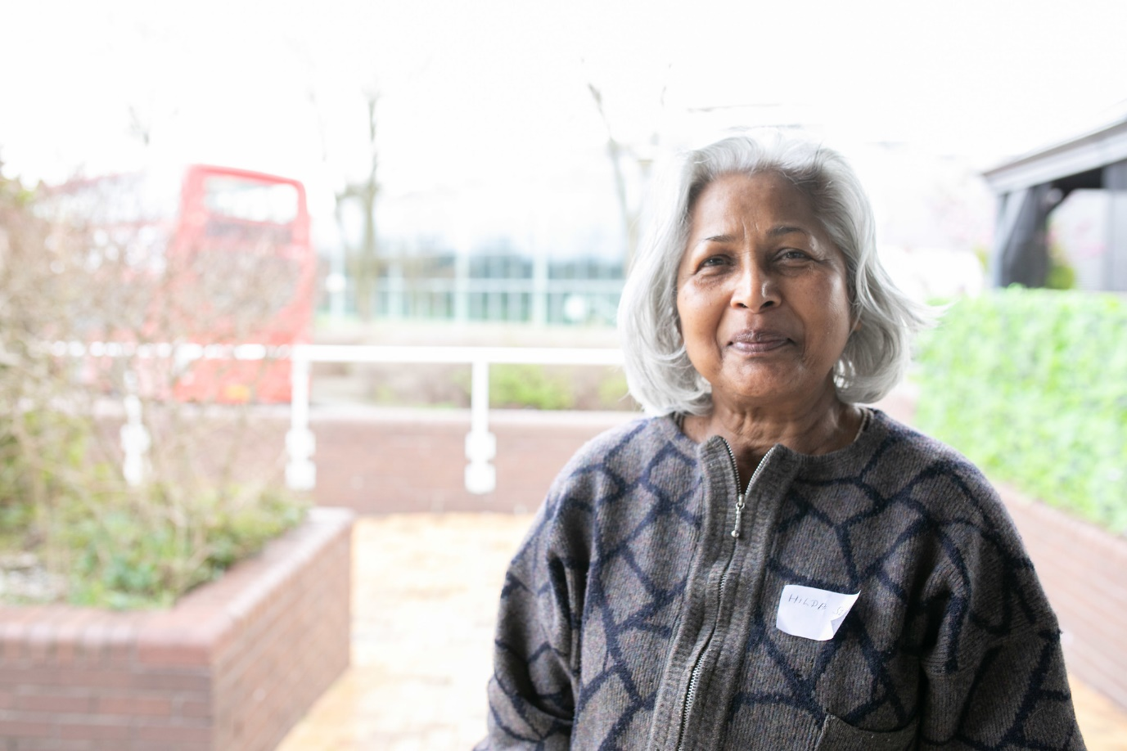
2021 - 2026

About us
Healthwatch is your health and social care champion. We make sure NHS leaders and other health and social care decision makers hear your voice and use your feedback to improve care.

How we work
There is a local Healthwatch in every area of England. At Healthwatch England, we support local Healthwatch to listen to what people like about services, and what could be improved, and we share these views with those with the power to make change happen. We also help people find information about health and social care services nearby.
Nationally and locally, we have the power to make sure that those in charge of services hear people’s voices and act on their feedback.

Our strategy: 2021 – 2026

Our vision
A world where we can all get the health and care we need.

Our mission
To make sure people’s experiences help make health and care better.

Our approach – what is important to us?
- Listening to people and making sure their voices are heard.
- Including everyone in the conversation – especially those who don’t always have their voice heard.
- Analysing different people’s experiences to learn how to improve care.
- Acting on feedback and driving change.
- Partnering with the Government, health and care services and the voluntary and community sector to make care better whilst retaining our independence.

Our objectives
- To build a sustainable and high-performing network of local Healthwatch services.
- To find out the experiences of people needing or using health, public health and social care services.
- To seek the views of those who are seldom heard and reduce the barriers they face.
- To act on what we hear to improve health and care policy and practice.
- To build on and share our expertise in engagement.
- To be strong, well-governed and use our resources for the greatest impact.

Introduction
Over the next year, we'll work harder than ever to amplify the voice of those who are not being heard and to make sure people’s views lead to solutions that improve care for everyone.

Tackling health inequalities
The COVID-19 crisis has affected everyone, but some have been impacted more than others. The pandemic has highlighted long-standing health inequalities, but we risk these worsening if we can't deliver care delayed by COVID-19, recover economically and tackle other effects like social isolation.
The communities we serve should be central to any recovery in health and care. As the pandemic has shown, high-quality advice and information is key to enabling people to do more for themselves and get the best out of services. Quickly understanding the experiences of different communities is critical to spotting trends, identifying best practice and solving problems.
This is why understanding and amplifying the views of those who are not being heard by health and care services is such a focus of our updated strategy and this business plan.

Building from a strong base
Last year, we helped nearly a million people to share their care experiences or access advice and information. This in turn, led to over 5,000 recommendations for national and local services about how they could improve support. These figures are a testament to our strong links with local communities and services and the trust people place in our role as an independent advocate.
Our updated strategy and business plan emphasise how we will build on this strong base. Unequal access to care can be influenced by many factors; where people live, their ethnicity, their income and the health conditions they face. This is why we will intensify our focus on understanding the best ways to engage different sections of the community and share our knowledge so other organisations can learn from our findings and approaches.
Our network of local services and the staff and volunteers who run them are at the heart of Healthwatch. We will continue to support them to get the funding and build the skills they need to run a high-quality service in every area of England.
Previous investment by Healthwatch England in digital infrastructure and communications paid dividends during our response to the COVID-19 pandemic, but we need to do more. We will continue to pilot better ways to gather, understand and action people’s feedback.
Above all, we need to make sure that people's experiences drive change at every level of the care system. In the year ahead, we will do more across many health and care issues, to make sure our evidence improves policy and practice. With legislation in train to reform the structure of the NHS, we will also work to ensure people’s views are heard at every level of decision-making.

Achieving more together
You can play your part in making sure everyone can get the health and care they need. If you use NHS or social care services, why not share your experiences with us to help make care better. If you support people who face unequal access to care, direct people to us, or work with us to engage local communities. If you are a health or social care professional, talk to us about the issues your community has raised and share the improvements you have made.
Recovering from the COVID-19 pandemic will not be easy, but by working with local people, partners and health and care services, we will accomplish more together.

Imelda Redmond CBE, National Director

Supporting local Healthwatch services

Our objective
To build a sustainable and high-performing network of local Healthwatch services.

Steps along the way
- Provide an annual plan of training and development opportunities for local Healthwatch staff and board members.
- Help local Healthwatch to demonstrate their impact and effectiveness.
- Work with local councils to show what a high-quality Healthwatch service looks like and help protect funding for them.
- Help local Healthwatch secure the funding they need to run a good service.
- Provide the resources and tools local Healthwatch need to carry out their work.
- Help local Healthwatch to be more diverse organisations.
- Support local Healthwatch to focus on equalities, diversity and inclusion in their work and improve their confidence in engaging with specific groups.
- Influence how local Healthwatch is involved in regional health and care decision-making, such as Integrated Care Systems.
- Roll out our updated brand purpose and values to local Healthwatch.

Signs of success
- Local Healthwatch staff, board members and volunteers value the support we offer and feel they have the right skills and tools to carry out their work.
- Local Healthwatch use our updated brand resources to engage local communities.

Providing advice and encouraging feedback

Our objective
To find out the experiences of people needing or using health, public health and social care services.

Steps along the way
- Provide digital tools to help local Healthwatch engage local people, and easily analyse and share their insight with us.
- Strengthen our approach used to run campaigns locally, regionally and nationally.
- Continue to provide high-quality advice and information about health and care services to the public.

Signs of success
- People who access our advice and information content rate it as useful.
- We have explored and assessed digital tools that will help us engage with more people.

Reaching out to those who are not being heard

Our objective
To seek the views of those who are seldom heard and reduce the barriers they face.

Steps along the way
- Identify the barriers that result in certain groups going unheard and how we can play a role in addressing these barriers.
- Develop a campaign that increases feedback from those who are least likely to engage with us, particularly from minority ethnic backgrounds.
- Improve our understanding of the health inequalities experienced by seldom heard ethnic minority groups.

Signs of success
- We receive a higher proportion of feedback from ethnic minority groups about their experiences of health and social care.
- Our policy and research work focus on equalities in health and social care, resulting in a change to services.

Improving health and care services

Our objective

To act on what we hear to improve health and care policy and practice.

Steps along the way
- Influence how people access care from their GP or dentist based on the experiences people share with us.
- Carry out three research projects looking at:
  - People’s experiences of digital healthcare.
  - Black, Pakistani and Bangladeshi people’s views of the COVID-19 vaccine.
  - Social care reform.
- Continue responding to issues as they arise, carrying out more responsive research to ensure changes to services have people at the heart of them.
- Increase our confidence to hold health and social care commissioners, providers and systems to account, both locally and nationally.
- Policymakers and health and social care professionals access and act on our evidence.

Signs of success
- More stakeholders are aware of our organisation and our role.
- More stakeholders value our work both nationally and in local communities.

Promoting better public engagement in care

Our objective

To build on and share our expertise in engagement.

Steps along the way
- Understand our approach to engagement as one network and the unique value we can offer.
- Map out other leaders in engagement and potential sources of income.
- Assess our strengths and weaknesses on engagement and use this to develop an engagement plan for us and the network.

Signs of success
- We set a benchmark for good engagement and use it to track our progress as experts in the following years.

Building a stronger organisation

Our objective
To be strong, well-governed and use our resources for the greatest impact.

Steps along the way
- Review and improve our governance structures and processes.
- Carry out a review of our contracts and grants and reduce our management costs.
- Create a plan to develop the skills of our staff and provide them with opportunities to lead on projects.
- Develop a framework to help us understand our impact.
- Refresh our values to continue our commitment to equality and diversity issues.
- Create an inclusive and learning culture among our staff and committee.

Signs of success
- We publicly demonstrate our impact and how we carry out our strategy.
- Healthwatch England staff feel both involved in our overall objectives and that they are making a difference in their role.
- We carry out an Equality Impact Assessment for all our projects.

